CRM Project

Functional Specification - Enhancement

PP6_Pre-Move In View
CM_090_090_050_E
(CM_ENH_110)

Deliverable Name | CM_ENH_110
Date | 10/18/2010
Revision | V1.0
Signed off By | Functional lead/PP6 Owner
Signoff Date

TABLE OF CONTENTS

1. Version 3
2. Approvals 3
3. Priority Mention the Priority of the object from the FRICEW list in ILM. Processing Mode (check all that apply) 3
Low Medium High 3
4. Enhancement Requirements Description 4
5. Impacted Systems 4
6. Approach to be followed Total custom development of the PMI view is required. 4
7. Roles and Volumes 4
8. Security & Control Requirements 5
8.1 Security Requirements 5
8.2 Control/Audit Requirements 5
9. Dependencies 6
9.1 Development Dependencies 6
9.2 Run/Execution Dependencies 6
9.3 Archiving Dependencies 6
10. Execution Steps 6
10.1 Process Description 6
10.2 Process Flow 6
10.3 As-Is Systems Referred To 7
10.4 Processing Options 7
11. Enhancement Description 7
11.1 Detailed Description of the Enhancement 8
11.2 UI Design and Screen Flow 17
11.3 Access Method or Path for Enhancement 18
11.4 Required Custom Tables (if known) 18
11.5 Error Handling Rules 18
12. Enhancement Reconciliation & Testing Requirements 22
12.1 Data Validation 22
12.2 Testing Reconciliation 22
12.3 Performance Issues 23
13. Additional Information 23
Not Applicable. 23
14. Open Items 23
15. Functional Unit Test cases 23

Version
Ensure that any approved change requests that affect scope are documented in the revision history and include CR #.
Version | Change Description | Author | Date Released | Sections Impacted
Enter in the version number | Brief description of the change | Who made the change | Date change was made | Mention the sections impacted with this change
1.0 | Document Creation | Ronda Clandening | 10/18/2010
2.0 | Limit Tree display to active objects (Premise, Contract, Contract Account, and Business Partner. – Pages 15 - 16  Cancel Process - Added popup Cancel Process message when notifications exist – Page 16 | Judy Jarone | 02/07/2011 | Section 11.1
3.0 | Added Mock Up Screen for Service Environment – Page 15 | Ronda Clandening | 2/24/2011 | Section 11.1
3.1 | Change Request CHG03917 updates. Process framework Traffic Light logic described for system messages | Judy Jarone | 5/9/2011 | Section 1.5 (pg 21)
3.3 | Change Request CHG03972 Added New Mock Up Screen for PMI View Set | Ronda Clandening | 5/17/2011 | Section 11.1 and 11.2
3.4 | Change Request: CHG04187  Added Numerous Bad Debts BOL Tree attribute & warning message in 11.1 (Page-15) and 11.5 (Page-22)  Change Request: CHG04059  11.1 (Page-10) Updated the mock up screen to Re-position Positive ID Request and Re-Use Business Agreement for increased Usability  Change Request: CHG03973  11.2 (Page-17) updated Screenshot to show Cancel Process button mock up placement | Sanjeev Singh | 8/02/2011 | Section 11.1 and 11.5

Approvals
The individuals listed below will be required to review and approve this document.
Reviewers Title | Reviewer Role | Name
Technical Team Lead | Approve | V. Krishna Karunakaram
CRM Functional Team Lead | Approve | Robert Smeltekop

Priority
Mention the Priority of the object from the FRICEW list in ILM.
Processing Mode (check all that apply)

Low Medium High

Enhancement Requirements Description

The Pre-Move In View will be used during the creation of a New Contract. It will be used to validate FACTA requirements for certain business roles, provide a user a view of SD contracts related to the business partner and premise, provide a user an overview of the Technical Environment to help the user identify existing conditions at the premise, determine if Positive ID is required, allow the user to re-use a business agreement, and provide a user with automated system messages (described in detail below) if necessary.

Impacted Systems

CRM 7.0 Web IC : CRM 7.0 Web Client Interaction Center Production System
ECC 6.0 / IS-U ECC 6.0 / IS-U : Back End Production System (Enterprise Central Component)

Approach to be followed
Total custom development of the PMI view is required.

Roles and Volumes

In terms of volume, this is a high frequency process that could be performed 100’s of times in a day by several of the business roles.

Role | Estimated Volume Requirement | Comments
List name of role; should come from the list of security roles | Enter the estimated volume requirements that will be needed by the Go-Live date | Enter other comments including if this development will require additional communication and/or training
CSR 2 | **times per day | The VCC performs over 1,000,000 New Contract Per year
CSR 3 | **times per day
CSR 4 | **times per day
VCC MGMT | **times per day
BCOS | 75times per day
Billing | **times per day
Consumer Affairs | **times per day
Revenue Recovery | **times per day
Gas Trans | **times per day

Security & Control Requirements

Security Requirements

This enhancement will be available to the following business roles:

CSR 2
CSR 3
CSR 4
VCC MGMT
BCOS
Billing
Consumer Affairs
Revenue Recovery
Gas Trans

- CM-090-090-15-S Security will be handled through business Roles. We are limiting the Contract Management Work Center by business role.
- CM-090-090-25-S Social Security and Driver’s License Masking. Control Impact – Validate existing ECC control of masking of a business partner’s social security number and driver’s license is implemented in CRM Web IC 7.0. Certain groups of employees are given access to full social security and driver’s license during change and display. Object ‘ZSENSITIVE’ is given through role ZMCCS_BP_SENSITIVE_XX_0000. This should continue in CRM Web IC 7.0.
- CM-090-09027-S Validation for FACTA will occur during CRM New Contract process as per business role, during the New Service request process as per business role, and during Partner Changes as per business role, if BP has the role of a “Contract Partner” and the type of “Person”. The validation will be applied to all profiles (mandatory for the CSR profile and optional for non-CSR profile).
- CSR 1’s are excluded from Contract Management Processes.

Control/Audit Requirements
<Describe any control requirements that need to be put in place as a result of this development object>.
- If applicable, please answer the question and also provide detail to the question.
- The questions listed below are not all inclusive to the control requirement that may be required. If there are any other controls requirements please document them as well.

- Indicate if this enhancement is being developed to address a control requirement?
- Financial/SOX Impact - Does the enhancement have any impact to financial reporting? If yes, is the amount significant (i.e. greater than $35 million annually)? Please provide an estimate.
- Regulatory Impact - Does the enhancement have any impact to regulatory compliance (i.e. FERC, NERC, etc)? If yes, please provide a reference to the rule and describe the impact.
- Operational Impact - Is the enhancement relied upon for a mission critical process or providing services to customers? If yes, please identify the mission critical process and describe how this enhancement is used in the context of this process.

CRM_030, CRM_101

Dependencies

Development Dependencies

FACTA PP6 - CRM.PP6.CM-090-090-220-E_FO_ENH_3860_FACTA Compliance
CM_090_090_220_E and PP6 CM-090-090-055-E_ MD_ENH_010 Sensitive Data Masking for Business Partner

Run/Execution Dependencies

Not Applicable. Once this development is complete all other process steps created for Create New Contract will become dependent on this development.

Archiving Dependencies

Not Applicable

Execution Steps

Process Description
This process may be accessed in two ways:
- A user may click directly on Contract Management Work Center
- A user may select the dropdown from Contract Management Work Center, and then select the sub menu New Contract (This will be the Best Practice method)

Process Flow

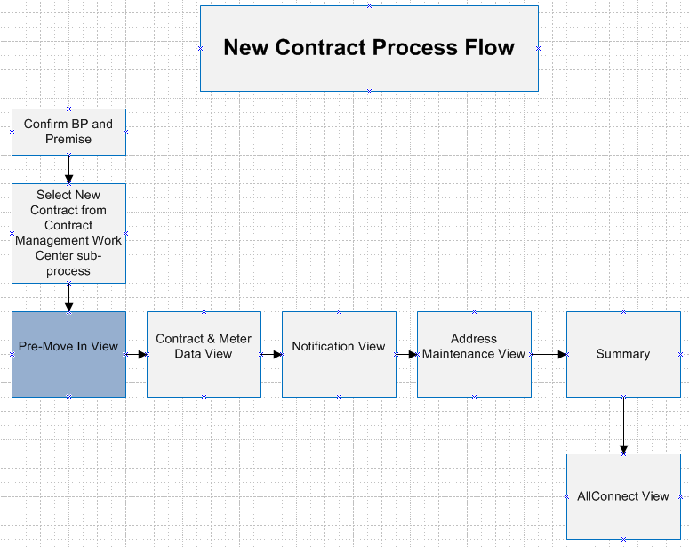

As-Is Systems Referred To

CRM 5.0 Win IC : Win Client Interaction Center - Production System
ECC 6.0 / IS-U ECC 6.0 / IS-U : Back End Production System (Enterprise Central Component)

Processing Options
Processing Mode (Select one of the following)
Batch Online – via Transaction Code Online – via Menu Path
On demand

Frequency (Select one of the following)
Daily
Weekly Quarterly
Monthly Annually
Other (If other, describe here)

Lifetime of Development (select one)
Permanent
Temporary, e.g. until rollouts are complete, specify details here

Enhancement Description

Total custom development of the PMI view is required.

Detailed Description of the Enhancement

One step of the New Contract Process is the Pre-Move-In Verification View Set, or otherwise known as the PMI View Set. The PMI View Set is the first process step in which the end-user, such as a Customer Service Representative, will see once a Business Partner and Premise have been confirmed and Contract Management, New Contracts is selected.

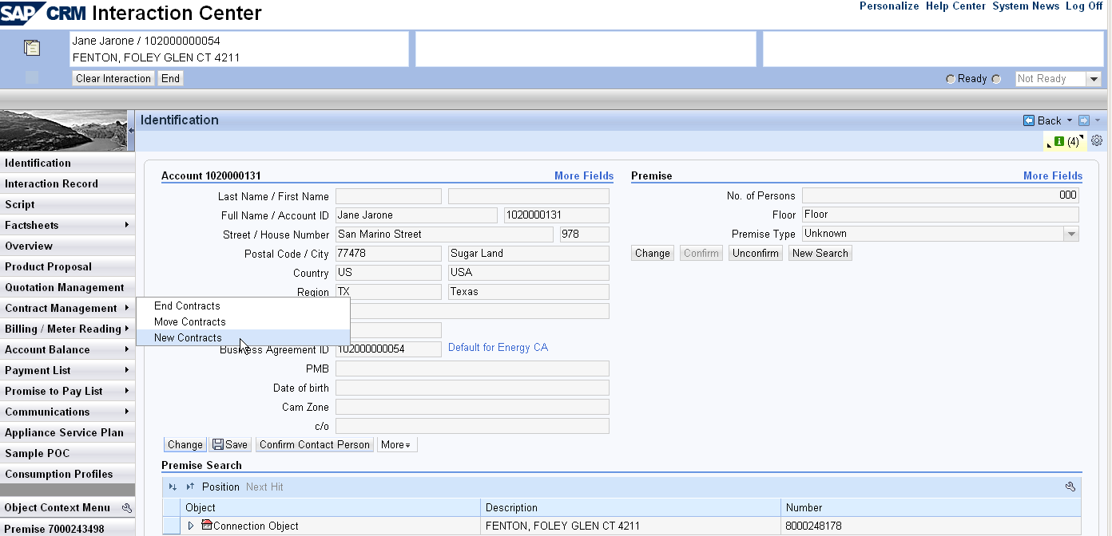

The PMI View Set is comprised of 6 different views. For ease of viewing this document each view will be broken into a section.

Detailed system messages will be in section 11.5 of this document and numbered in a table, along with Error Messages.

Also in section 11.5 are Dialogue Pop Ups (Prompts) which are displayed prior to the presentation of the PMI View. When a user selects the sub process of New Contracts from the Contract Management Work Center a check will need to be done for the Dialogue Pop Ups (Prompts).

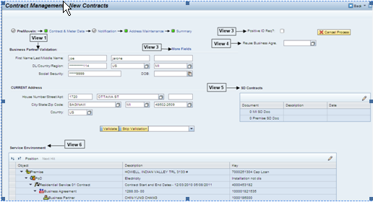

View (1) Business Partner Validation (FACTA) – To be in compliance with state and federal regulations under the Fair and Accurate Credit Transactions Act (FACTA), Consumers Energy was required to provide an identification validation process by May 1, 2009.

In order to be in compliance with FACTA, identity validation will take place during the CRM New Contract process as per business role, during the New Service request process as per business role, and during the following Business Partner Changes as per business role:
- Name
- Date of Birth
- Social Security Number
- Michigan Driver’s License
- Michigan State Issued Photo ID
- Passport
- US Military ID
- Native American Tribal ID
FYI – Notification to Fraud will be performed by the Equifax Interface Function Module Z_DO_EQUIFAX_CHECK.
This document details the SAP design requirements that will meet the FACTA compliance for New Contracts.

Business Partner Validation (FACTA) - FACTA validation will occur for Business Partners with the role of “Contract Partner” and the type of “Person”. The validation will be applied to all roles (mandatory for the CSR roles (CSR 2, CSR 3, and CSR 4) and optional for the non-CSR roles).

Non-CSR business roles may decline FACTA validation by providing a reason via the ‘Skip Validation’ dropdown. The system will not allow the user to continue the New Contract process unless validation is performed or a ‘Skip Validation’ reason is provided. The CSR role will not have the ‘Skip Validation’ button displayed (hidden or grayed out).

The customer is asked to provide Social Security and/or Michigan Driver’s License numbers, previous address, and date of birth. If the customer is unable or unwilling to provide the ID necessary to perform validation then the customer will be asked to provide positive ID prior to the completion of their request for service.

Validate Button - To reduce the cost involved in repeated attempts to validate the business partner the ‘Validate’ button should be disabled after the first successful call is made to the interface. If call is not successful (FACTA passed) the Validate button will remain enabled. When the user clicks on the Validate button we will need a clock or process indicator, so the user will know when the Validate process is complete.

Skip Validation Button - Non-CSR users will be allowed to decline validation, but must provide a reason via the dropdown list box. The reason will be stored as a note on the Interaction Record for the New Contract creation.

Contacts – The FACTA contacts will be created in the FACTA Interface. The Positive ID Request (PIR) contacts and Security Deposit Request (SDR) contacts will be created in the Move In Workflow (WS93000115).

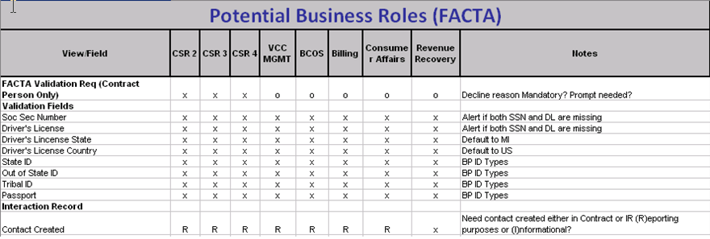

Refer to the PP6 CRM.PP6.CM-090-090-220-E_FO_ENH_3860 FACTA Compliance for all FACTA Requirements.

View (2) More Fields – Other forms such as State ID, Out-of-State Driver’s License, etc. will be accepted and will be available in the ‘More Fields’ view. The user will be able to insert, modify, and delete a limited number of ID Types. If necessary the user will be able to return to the default view by selecting the ‘Return’ icon.

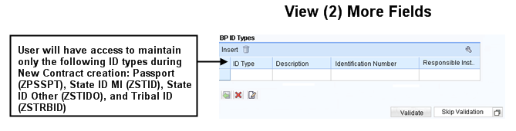

View (3) Positive ID Req? – In addition to the FACTA validation, the system will determine if Positive ID is required automatically. There are three rules that determine if a PIR should be requested. The user may override the Auto PIR request. If the confirmed business partner is the owner of the property then the PIR check is suppressed. System messages will be used to communicate the PIR request to the user.
- Device Location Notes – Set auto PIR if the following notes exist on one or more device locations for the premise. Numerous Bad Debts (ZN), Unresolved Theft (ZF) (If both a ZF and Theft Complete (ZG) exist, then we will NOT request Positive Identification Request(PIR), or Fraud (ZD). See section 11.5 for detailed system message 1.5.

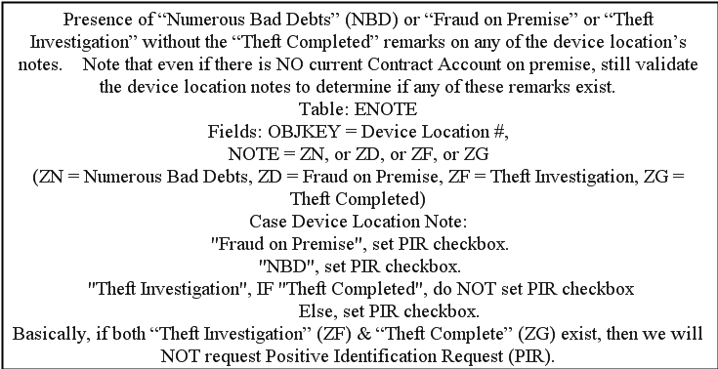

- Business Agreement Balance – Automatically set the Auto PIR if the active premise contract account has an account balance ≥$750.00 and the dunning level is ≥ 20. See section 11.5 for detailed system message 1.10.

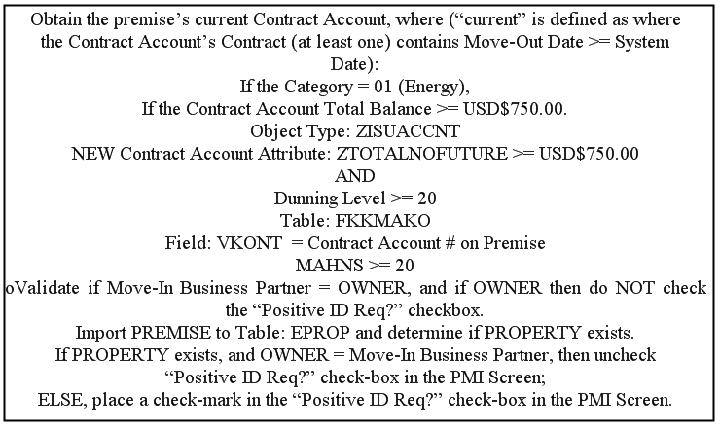

- Dunning Disconnect – Automatically set the Auto PIR if any installation is disconnected or is pending disconnection due to dunning and the business partner associated with the disconnect reference object is different than the confirmed business partner. See section 11.5 for detailed system message 1.15.

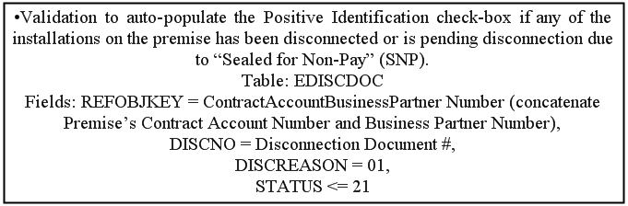

ECC will continue to create contacts related to Positive ID, Security Deposit and FACTA.

View (4) Re-Use Business Agreement? – A new business agreement is normally created for every New Contract created. If no business agreement is confirmed within the New Contract Process then a new business agreement will be created automatically. It has been decided that a business agreement confirmed prior to starting the New Contract process will be ignored. A business agreement may be re-used by selecting the ‘Re-Use Business Agreement’ checkbox. Once the checkbox has been marked a dropdown list box will appear and the user will select the business agreement. A business agreement may be re-used under the following conditions:
- The system determines that an additional service, i.e, gas, is being added to a business partner’s active service for the same premise (residential only). The system will then automatically confirm the correct business agreement for re-use. (Example: BP calls to state they had gas service installed. The user will Create New Contract for residential gas installation for BP who already has active electric contract for same premise) and during the New Contract process the system will automatically re-use the Business Agreement for the electric contract.
- The user has the option of re-using an existing business agreement. This is typically due to activities related to account correction.

View (5) SD Contracts – This area will display active SD contracts related to the business partner and premise. View transaction VA43 and contract 40004339 as an example in ECD 150.
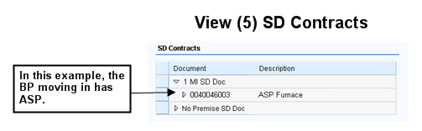
See logic below:
Field Name | Data Source | Description
Document | VBAK~VBELN | Sales Document Number
Description | VBAP~ARKTX | Sales Document Description

View (6) Service Environment – The user will be able to view the CRM Technical Environment. This area provides the user with an overview of the service address to help identify existing conditions at the premise, along with icons which represent the state of the premise (active, inactive, lock, partial lock). The tree view should display only the confirmed premise and information as of the system date. Only active business partners, business agreements, and contracts should be displayed. Based on the UI Document Potential Business Roles the following fields will be available for the Service Environment tree:

The tree below is located under the Profile Name: ZPMI_SL2

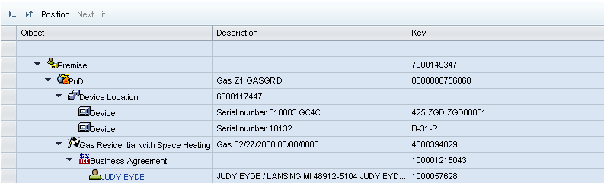

The Service Environment BOL Tree needs to be Enhanced at the Device Location level for Numerous Bad Debts. If Device Location Note includes code ZN = Numerous Bad Debts (from table ENOTE), then the DESCRIPTION on the Service Environment column for the Device Location would display as 'NUMEROUS BAD DEBTS'.

Also, if Device Location Notes = ZD or ZF (Theft/Fraud), then the DESCRIPTION on the service Environment Column for the Device Location would display as ‘Theft/Fraud exists on Premise’

The attributes in the spreadsheet below will need to be available for each Object in the tree above.
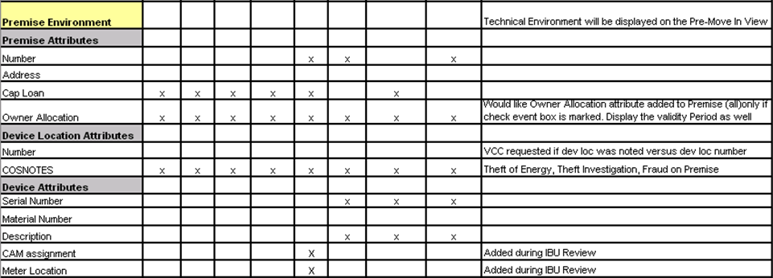

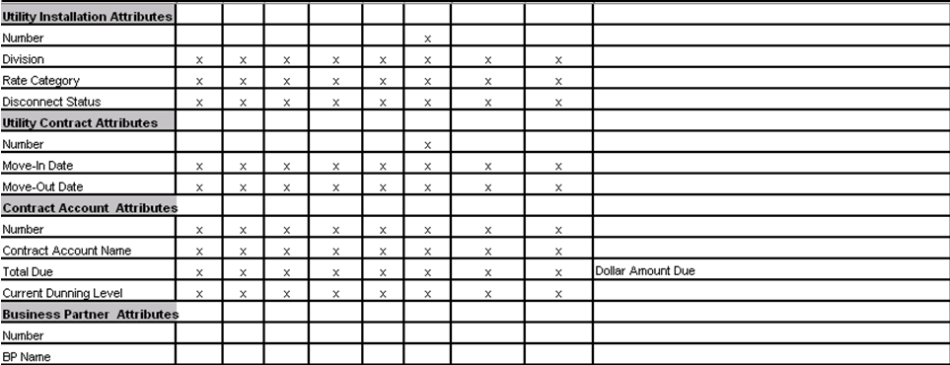

Description | Attribute/Table/Field
Premise Number | EVBS Only the confirmed premise should appear
Premise Address | ZPremises.ZPremAddr
Cap Loan | ZPremises.CAPLoan
Owner Allocation | ZPremises.ZPropertyOnwerAlloc
Dev Loc Number | EGPLD
COSNOTES | ZDeviceLocation.COSNotes
Device Serial Number | IT0B
Material Number | ZDEVICE.MaterialNumber
CAM Assignment | BUT000~BPKIND
Meter Location | ZDEVICE.ZDevLocDetails
Meter Type | ZDEVICE.DeviceType
Installation Number | EANLD
Division | INSTLN.Division
Rate Category | INSTLN.ActRateCat
Disconnect Status | INSTLN.ZDiscDocStat
Contract Number | EVERD Only Active Contracts should be displayed
Move In Date | ZUtilContract.MoveInDate
Move Out Date | ZUtilContract.MoveOutDate
Contract Account Number | FKKVKBP – Only the active Business Agreement should appear in the Tree.
Contract Account Name | ZUtilAccount.ContractAcctName
Total Due | ZUtilAccount.ZTotalNoFuture
Current Dunning Level | ZUtilAccount.ZDunningLvlCurrCdwLabel
BP Number | BUS_JOEL_MAIN – Only the active business partner should be displayed
BP Name | ZUtilBusinessPartner.Name

Cancel Process
If the user decides to cancel the process by selecting the ‘Cancel Process’ button then the confirmation dialog popup should be displayed. If the user confirms cancellation then the Account Identification View should be displayed.

If notifications have been create in the Notification View prior to selecting the Cancel Process button then display the follow:

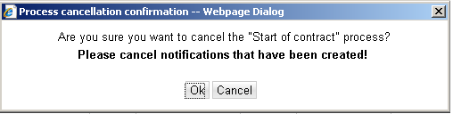

If notifications have not been created, display the following:
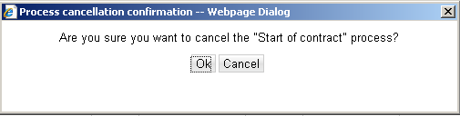

Press CANCEL. The system should remain in the current view.

Press OK. The system should navigate to the BP Identification view.

UI Design and Screen Flow
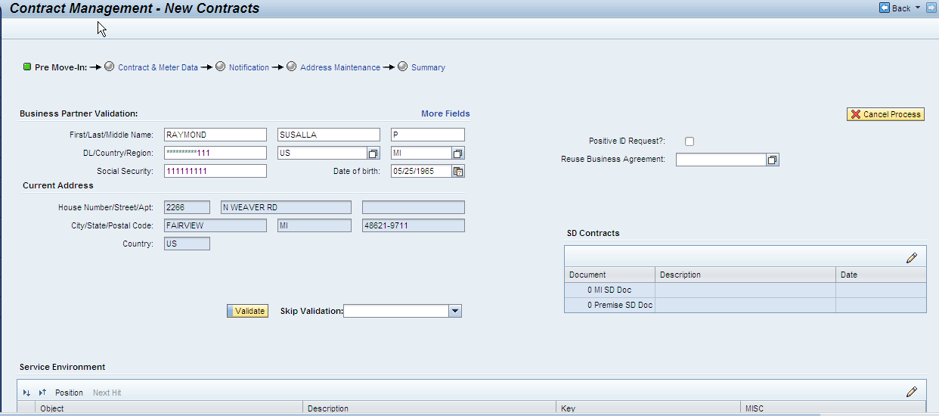
When the user Submits the New Contract, the following fields will be saved to the Business Partner:

Changes made to any of the following fields will be SAVED to the BP upon Submit
First Name
Last Name
Middle Initial
Drivers License Number
Drivers License Country
Drivers License Region
Social Security Number
Date of Birth
Passport (ZPSSPT)
State ID MI (ZSTID)
State ID Other (ZSTIDO)
Tribal Id (ZSTRBID)

Access Method or Path for Enhancement
Execution: Custom Transaction Code:
Menu Path:
Standard Transaction Code:
Other: CRM 7.0 Web IC Navigation

Required Custom Tables (if known)
Table Name: NA
Table Description: NA
M/O | Field Description | Type (text or numeric) | Maximum Field Length | Value Restrictions? | Validations?
Mention M if the field is mandatory and O if the field is optional | Enter the field description | Enter the type | Enter the max. field length | Enter any value restrictions | Mention if any validations are required or else mention NA

Error Handling Rules
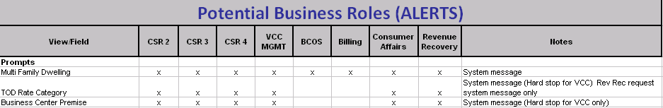

(Note: Use of Pop-ups and Alerts at appropriate events)
Dialogue Pop Ups (Alerts) Displayed Prior to the Presentation of the PMI View – Message to Display | Table
Multi Dwelling Determination - A separate window will pop-up if a Multi-Dwelling Rate has been identified on the installations in which the customer is moving into. The window is purely a simple warning to alert the customer representative (CSR) that this customer is moving into a premise consisting of installations with Multi-Dwelling Rate Categories. This message is displayed prior to the presentation of the PMI View. Message:  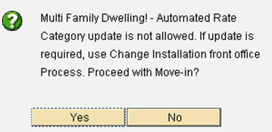  When Continue is chosen the user is taken to the PMI View. If Cancel is chosen the user will be returned to the Identification View.  There will also be a system message included on the Product Questionnaire View PP6: Multi Family Dwelling! – ‘Automated Rate Category Update Not Allowed’ if Continue is chosen. | These rate categories are sourced from table ZTFO_RATECATCAT for category = MULTDWELL
TOD and TOU Alert - If the rate category for the current time slice is RT_1010 or RT_2010, warning message 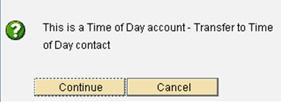 is displayed prior to the presentation of the PMI View. When Continue is chosen the user is taken to the PMI View. If Cancel is chosen the user will be returned to the Identification View.  There will also be a system message included on the Product Questionnaire View PP6: Multi Family Dwelling! – ‘Automated Rate Category Update Not Allowed’ if Continue is chosen. | These rate categories are sourced from table ZTFO_RATECATCAT for category = TOU  Set the Continue button as the first button, but set the Cancel button as the default button.  Going forward with CRM 7.0 the CSR role will not be allowed to select Continue. This will be a hardstop for the CSR role (refer to the Potential Business Roles (ALERTS) UI document below). Other roles will be allowed to continue.
MV90 Alert - If the MRU for the current time slice begins with MV90, warning message 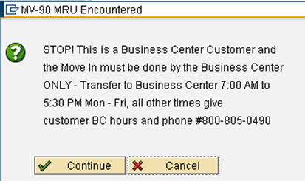 is displayed prior to the presentation of the PMI View. When Continue is chosen the user is taken to the PMI View. If Cancel is chosen the user is returned to the Identification View. | Set the Continue button as the first button, but set the Cancel button as the default button.  Going forward with CRM 7.0 the CSR role will not be allowed to select Continue. This will be a hardstop for the CSR role (refer to the Potential Business Roles (ALERTS) UI document below). Other roles will be allowed to continue.
Business Center Alert - If the move in business partner is defined as a “Business Center” customer (EKUN- CLASSIFICATION = 01), warning message  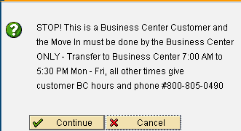 is displayed prior to the presentation of the PMI View. When Continue is chosen the user is taken to the PMI View. If Cancel is chosen the user is returned to the Identification View. | Business Center customer = EKUN – CLASSIFICATION = 01  Set the Continue button as the first button, but set the Cancel button as the default button.  Going forward with CRM 7.0 the CSR role will not be allowed to select Continue. This will be a hardstop for the CSR role (refer to the Potential Business Roles (ALERTS) UI document below). Other roles will be allowed to continue.
Business Center Alert (Forced Move Out and Current BP) - If a current active contract exists for the MI premise, and the business partner associated with the current active contract is defined as a “Business Center” customer (EKUN- CLASSIFICATION = 01), warning message  is displayed prior to the presentation of the PMI View. When Continue is chosen the user is taken to the PMI View. If Cancel is chosen the user is returned to the Identification View. | Business Center customer = EKUN – CLASSIFICATION = 01  Set the Continue button as the first button, but set the Cancel button as the default button.  Going forward with CRM 7.0 the CSR role will not be allowed to select Continue. This will be a hardstop for the CSR role (refer to the Potential Business Roles (ALERTS) UI document below). Other roles will be allowed to continue.

If no error or warning system messages are displayed in this view the process framework traffic light will be green and the user will be allowed to submit the contract(s) in the summary view.

Traffic Light | Description
Green | The user will be allowed to submit the contract(s) in the Summary View
Yellow | The user will be allowed to submit the contract(s) in the Summary View
Red | User is not allowed to move away from the Pre Move-in View

CRM 7.0 System Messages to Appear on PMI View | Traffic Light
1.5 - “ Device Location Notes, Theft or Fraud exists on premise” (FACTA & PIR model statement will appear on ‘Summary’ view PP6) | Yellow
1.5- “Device Location Notes, Numerous Bad Debts on Account (if Device Location Note=ZN, numerous Bad debts) | Yellow
1.10 - “Previous BA balance ≥ $750 and Dunning Level ≥ 20” (FACTA & PIR model statement will appear on ‘Summary’ view PP6) | Yellow
1.15 “Possible Disconnect Due to Dunning” (FACTA & PIR model statement will appear on ‘Summary’ view PP6) | Yellow

Error Messages – If a condition exists that results in an error message the user will not be allowed to continue the New Contract Process unless the condition is resolved or the process is cancelled via the ‘Cancel Process’ button.
Message | Solution | Traffic Light
“FACTA Validation Required” | User must perform FACTA validation prior to transitioning away from the Pre Move In View. This message is only applicable for CSR business roles. | Red
“FACTA Validation or Skip Validation is Required” | The user must either perform FACTA validation or provide a Skip Validation reason prior to transitioning away from the Pre Move In View. This message is only applicable for non-CSR business roles. | Red
1.1 - “Enter BP Previous Address” (FACTA & PIR model statement will appear on ‘Summary’ view PP6) | User must enter previous address for BP if fields are blank prior to transitioning away from the PMI View. | Red
1.3 – “Enter Date of Birth” | User must attempt to enter ‘Date of Birth’ if field is blank, prior to transitioning away from the PMI View. User will be allowed to continue if field is blank. | Red

Enhancement Reconciliation & Testing Requirements

Data Validation
Data validation will require the expected test cases execution and verifying the results based on business requirements. CRM project team along with their business support teams will be responsible to ensure this enhancement works.

Testing Reconciliation
This enhancement will be tested by the teams (their security roles) who perform the New Contract process. Teams will include CRM project team, BTS support team, Call Center, BCOS, Revenue Recovery, Consumer Affairs, and Billing.

Performance Issues

Not Applicable.

Additional Information

Not Applicable.

Open Items
Item # | Detailed Description | Proposed Solution
Insert number | Describe the item | Describe the proposed resolution

Not Applicable.

Functional Unit Test cases
Test Condition Description | Input Data | Expected Results | Actual Results/Comments
Click on FACTA validation button |  | FACTA validation is performed
Click on Skip validation button |  | FACTA validation is NOT performed
BP has Condition of Service on Account |  | COS system message is presented
Re-use a BA – Residential account, BP currently has electric service and is requesting gas service be put in their name |  | BUAG for electric is automatically re-used for gas
BP moving in has ASP |  | SD Contract for BP moving in is shown on Service Environment
Premise has ASP |  | SD Contract is shown on Service Environment for premise
BP moving in and premise moving into has ASP |  | SD Contracts for BP moving in and Premise are shown on the Service Environment
Premise is showing inactive icon on environment |  | Inactive icon is shown on the Service Environment
FACTA Pass – Auto PIR Fraud |  | System message for Fraud is displayed
FACTA – Declined – Manual PIR |  | System message for PIR is displayed
FACTA Pass – Remove Sec Dep
FACTA Pass – Sec Dep Final Bill
FACTA Pass – Auto PIR Theft, Bankruptcy |  | System message for PIR, Theft, Bankruptcy is displayed
FACTA Passed – Theft Completed |  | No system message is displayed
NON CSR FACTA Pass – Auto PIR Premise Bal ≥ $750 |  | System message for PIR is displayed
CSR FACTA Pass = Auto PIR removed by CSR for premise bal ≥$750 |  | User removes PIR, no system message is displayed
CSR FACTA Pass – Auto PIR Dunning Disc at Premise |  | System message for PIR and Dunning Disc is displayed
CSR Organization – Auto PIR suppressed due to Owner Allocation |  | No system message is displayed
CSR Organization – Re-Use Existing BA |  | User re-uses BA
CSR Business Center Customer |  | Pop-up displayed prior to PMI View and CSR is unable to continue
CSR Business Center Premise |  | Pop-up displayed prior to PMI View and CSR is unable to continue
BCOS Agent – Business Center Customer |  | Pop-up displayed prior to PMI View and user is able to continue
BCOS Agent – Business Center Premise |  | Pop-up displayed prior to PMI View and user is able to continue
CSR FACTA Pass – Multi Dwelling |  | Pop-up is displayed prior to PMI View
CSR TOD/TOU |  | Pop-up displayed prior to PMI View and CSR is unable to continue
CSR MV90 |  | Pop-up displayed prior to PMI View and CSR is unable to continue
BCOS Agent TOD/TOU |  | Pop-up displayed prior to PMI View and user is able to continue
CSR Auto Re-Use BA – Residential BP currently has electric service and has now installed gas service |  | System automatically re-uses BA for electric service
Non CSR FACTA Pass Connection Fee Required |  | System message for PIR is displayed
Non CSR FACTA Pass – Connection Fee Removed |  | User removes connection fee and no system message is displayed
Non CSR FACTA Fail - Connection Fee Suppressed |  | FACTA failed, Connection Fee is suppressed and no system message displayed
CSR No ID Provided |  | FACTA Failed and PIR message is displayed
CSR FACTA Error |  | System message is displayed

